  Bluffton Youth Baseball Sign-Up Dates and Tryouts for the 2025 Season | 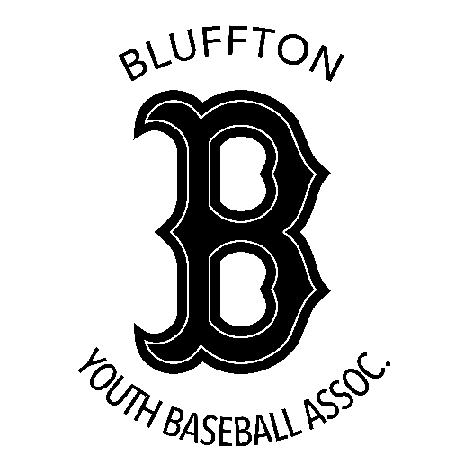
  It is with great honor to announce some important upcoming dates for our 2025 Bluffton Youth Baseball season. We are very excited to start thinking about our Summer’s favorite past time: BASEBALL. Our league continues to grow and succeed year after year. None of this is possible without the continued support from our community, sponsors, volunteers, coaches and wonderful children. We encourage all kids with an interest in baseball to join.
  Below are the official sign-up dates for the upcoming 2025 season. All the sign-ups will be held at the Wells Community Boys & Girls Club at 1410 Wayne St. in Bluffton, IN. The fee to participate in each league will be $60 per child.
  Weekend Sign-Up Dates:
  Saturday March 1st 9am – Noon Wells County Boys and Girls Club Kitchen
  Saturday March 8th 9am – Noon Wells County Boys and Girls Club Kitchen
  Saturday March 15th 9am – Noon Wells County Boys and Girls Club Kitchen
  YOU CAN ALSO REGISTER ONLINE AT: wellscoyouthsports.org
  Evaluations and Draft Date: All Players Will Be Evaluated This Year
  Saturday April 5th @ Bluffton High School (Enter through door 2)
  8-YEAR-OLD EVALUATIONS: 9AM (If they do not meet the criteria for Farm League, they will revert to Minor League).
  JUNIOR LEAGUE EVALUATIONS: 10AM FARM LEAGUE EVALUATIONS: 12PM
  Cut-Off Date for both league age requirements is May 1st.
  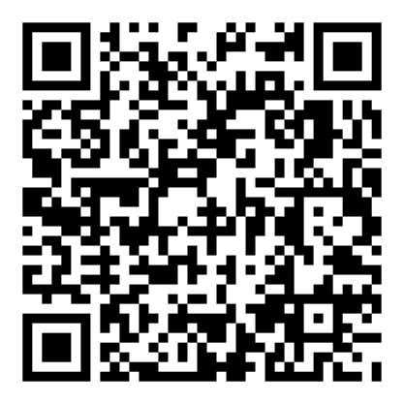
  Follow us on Facebook!
  Bluffton Youth Baseball Association
  Don’t miss out with the Spring and Summer fun of Bluffton Youth Baseball.
  All kids encouraged to join!
  Farm League: 8–10-year-olds
  Junior League: 11–13-year-olds
  BYB Association
  PO Box 227
  Bluffton, IN 46714
  President – Zach Bedwell
  blufftonyouthbaseball@hotmail.com
  bb

